www.ECPB.biz
ECPB Late C3-74 to 79 Corvette Electric Headlight Actuator Mounting Bracket
Installation Instruction
Read this second
Use the bracket marked with “LEFT” on the driver side. Use a C clamp or locking pliers to hold the bracket to the bottom of the bumper support bracket, align the bracket so the center of the hole to the outside of the car measures 2 7/8 inches to the end of the bumper support bracket and the
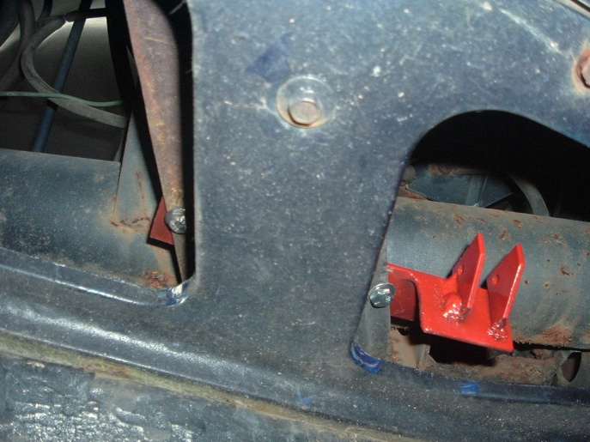
hole closer to the middle of the car should measure 4 inches to the end of the bumper support bracket. Both mounting holes are very close to the edge of the bumper support bracket. Now drill both ¼ inch holes and fasten with the supplied bolt and the flat bar (if needed install flat bar under support bracket) to the bumper support bracket. An alternative way to find the mounting location is to fasten the bracket to the bottom of the actuator and let it swing down to locate the holes to be drilled; they should be in reference to the dimension above. Repeat the same for the RIGHT or passenger side.
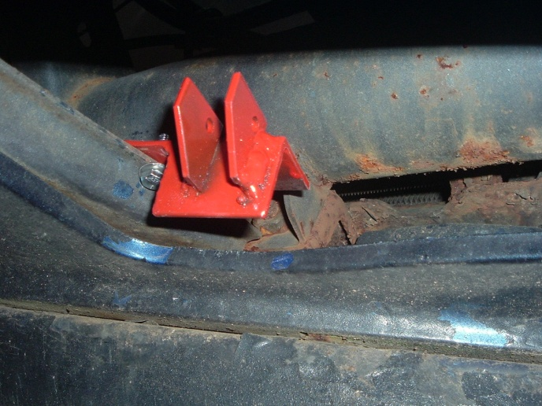
This is the end to measure to on the bumper support bracket
Align the electric actuator in between the mounting tabs and install the ¼” hex bolt with the lock nut. Do not fasten tight, make sure it has free play and a little of movement.

Copyright 2009 ECPB, LLC; All rights reserved; Patent Pending;

